**This game is incomplete, consider it as such.**

**Inputs:**

For the game to be played, it must be run using C++ library SFML. To do this, go to the source folder, compile and execute main.cpp

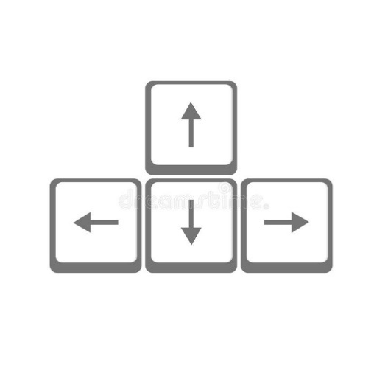

Rotated using space:



**Outputs:**

The game outputs the image displayed at the screen, including:

* Piece
* Board

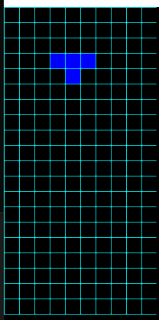

**Intent:**

Used as a point of comparison between my freshman and engineer critical thinking and programming skills. Also, just for fun.

**Scope:**

Consists of the classic Tetris recreated using C++. The game is intended to apply only the pieces movement, fall, turn and random generation.

**Tetris**

1. **Title**: Tetris (CPP)
   1. Designer and Programmer: Juan Pablo Ospina Bustamante
   2. Genre: Puzzle
   3. Platform: Personal Computer
2. **Gameplay and Content Synopsis**:

This is an implementation of the classic game Tetris; the game mechanics are faithful to the original

1. **License:**

The game is based on Tetris; therefore, its concepts, rules and practices are public, but the game itself, assets and source code follow the MIT License.

1. **Mechanics:**

A static board is shown on screen and pieces are generated randomly from a selection of 4 pieces. The pieces can be rotated, and they “fall” 1 block to the bottom of the board per second, the player can also choose to move the piece faster to the bottom.

As soon as a piece touches the board’s bottom or another piece, it stops, and another piece is generated.

1. **Technology:**

C++ and SFML library are used to develop this game

1. **Target Audience:**

Any audience can play the game.

1. **Game Mechanics:**
   1. **Camera**: A fixed 2D camera is used
   2. **Peripherals**:

Keyboard